
CHocolate sales
Mohanad Ibrahim Elsayed Elbadawy
ID: 234128

DR. SHADY ABDELHADI
DR. NOURAN AMR

About Dataset:
🍫 Chocolate Sales Dataset (2023–2024)
This dataset contains synthetic retail transaction data for chocolate sales across multiple stores, customers, and products during the years 2023–2024.
The dataset is designed for data analysis, machine learning, and forecasting projects, simulating realistic retail sales data typically found in the FMCG (Fast-Moving Consumer Goods) industry.
It can be used for tasks such as:
- Sales analytics
- Customer behavior analysis
- Retail performance evaluation
- Time series forecasting
- Machine learning experiments
Data Source: The data was obtained from Kaggle.com, a platform for open-source datasets.
Row Count: The dataset contains approximately 1,000,000 total orders (as shown in the 'Total Orders' KPI).
Time Period: The data covers a full calendar year from January to December.
Key Metrics: The report analyzes Total Revenue ($25.49M), Total Profit ($10.19M), and a Profit Margin of 40%.
Model View:
Include this description under your screenshot to show you understand the data structure:
- Model Type: I have built a Star Schema data model, which is the standard for efficient Power BI reports.
- Fact Table: The sales table is in the center as the fact table, containing all numeric transactions and foreign keys.
- Dimension Tables: I have surrounded the fact table with four-dimension tables: products, customers, stores, and calendar.
- Relationships: All relationships are configured with Many-to-one (*:1) cardinality and a Single cross-filter direction to ensure data integrity.

This screenshot:
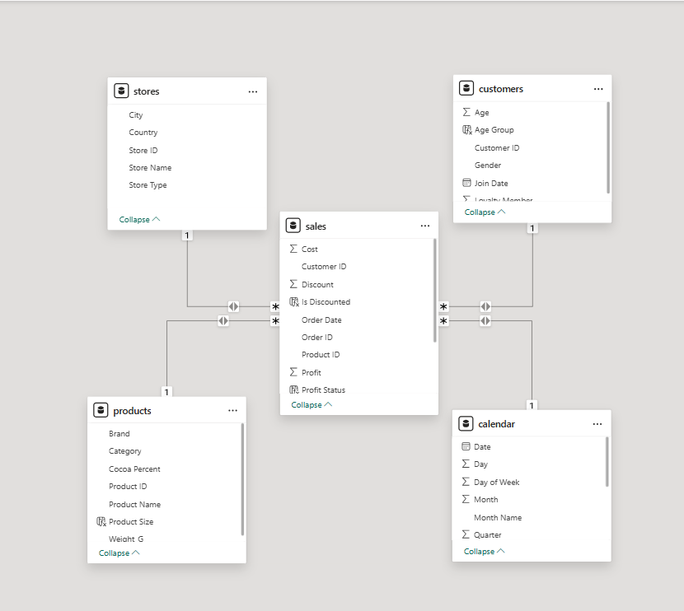

Page 1: Overview Analysis
The first page of my Power BI report provides a comprehensive summary of the business performance. Below is a detailed explanation of the components used:
- Executive Summary (KPI Cards): At the top of the report, I have included four KPI cards showing critical business metrics: Total Revenue ($25.49M), Total Orders (1M), Total Profit ($10.19M), and a Profit Margin of 40%.
- Dataset Description: On the top-left, a dedicated text box describes the dataset, its source, and the time period (2023–2024), fulfilling the requirement to explain the data context.
- Monthly Sales Trend (Line Chart): The "Total Revenue by Month" chart tracks sales fluctuations throughout the year. It clearly identifies February as the lowest revenue month ($1.98M) and shows peaks in months like January and March.
- Product Performance (Donut Chart): The "Total Revenue by Product" chart illustrates the revenue share by category. Dark Chocolate is the leading category, contributing 22.62% ($5.71M) of total revenue.
- Interactive Analysis (Slicers): I added vertical slicers for Month and Brand on the right side to allow users to filter the entire dashboard by specific timeframes or manufacturers.
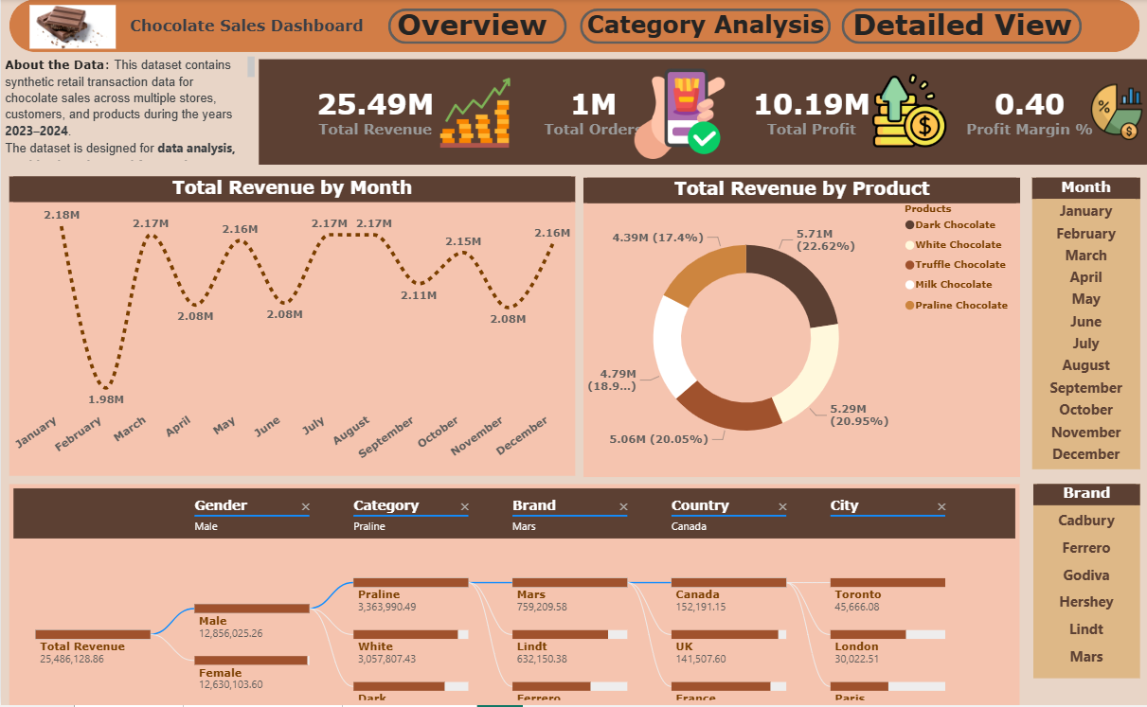
- Revenue Breakdown (Decomposition Tree): At the bottom, I utilized a decomposition tree to analyze how revenue is distributed across Gender, Category, Brand, and Location (Country/City). This allows for deep-dive root cause analysis of sales performance.
Page 2: Category Analysis
The second page of my report focuses on a deep-dive analysis of product categories and brand performance. It provides a more detailed view of the sales metrics compared to the initial overview.
- Total Quantity Trend (Line Chart): These visual displays the "Total Quantity by Month," showing the volume of items sold throughout the year. It identifies seasonal fluctuations in product demand, with a noticeable dip in February (233K units).
- Total Revenue by Product (Donut Chart): This chart visualizes the share of revenue each chocolate product contributes to the total. Dark Chocolate remains the top performer, accounting for 22.62% ($5.71M) of total sales.
- Brand Performance Matrix: I utilized a Matrix visual to show detailed metrics per brand, including Total Orders, Sum of Quantity, Total Profit, and Total Revenue. It also features a "Revenue Previous Year" column using Time Intelligence DAX to compare current performance against historical data.
- Revenue by Category (Bar Chart): This chart compares total revenue across different chocolate categories like Praline, White, and Dark. Praline leads this specific view with $6.7M in revenue.
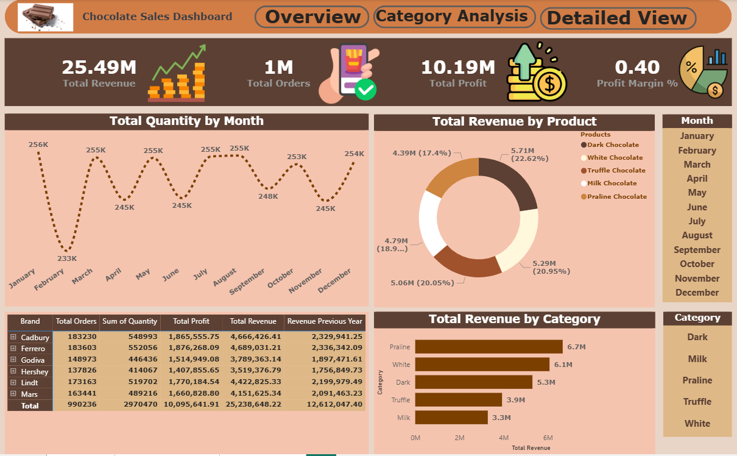
- Interactive Slicers: The page includes a vertical Month slicer and a Category slicer on the right side, allowing the user to filter all visuals by specific timeframes or chocolate types.

Page 3: Detailed View
The third page provides a granular look at the data, focusing on correlations and geographic distribution to answer specific business questions.
- Revenue vs. Quantity Correlation (Scatter Plot): This visual plots Total Revenue against Total Quantity by brand. It reveals a strong positive correlation, identifying brands like Cadbury as high-volume, high-revenue leaders.
- Demographic Analysis (Pie Chart): The "Total Revenue by Gender" chart shows an almost equal split in purchasing behavior, with Males contributing 50.44% ($12.73M) and Females contributing 49.56% ($12.51M).
- Geographic Performance (Map): The "Total Revenue by Country" map visualizes the global reach of the business, highlighting major markets in Europe and North America.
- Product Performance Table: This detailed table displays metrics for each chocolate type, including Total Orders, Sum of Quantity, Total Profit, and Total Revenue. It serves as a data grid for precise numerical review.
- Historical Comparison: A "Revenue Previous Year" column is included in the table, calculated using DAX Time Intelligence, allowing for a direct comparison of current growth against the previous period.
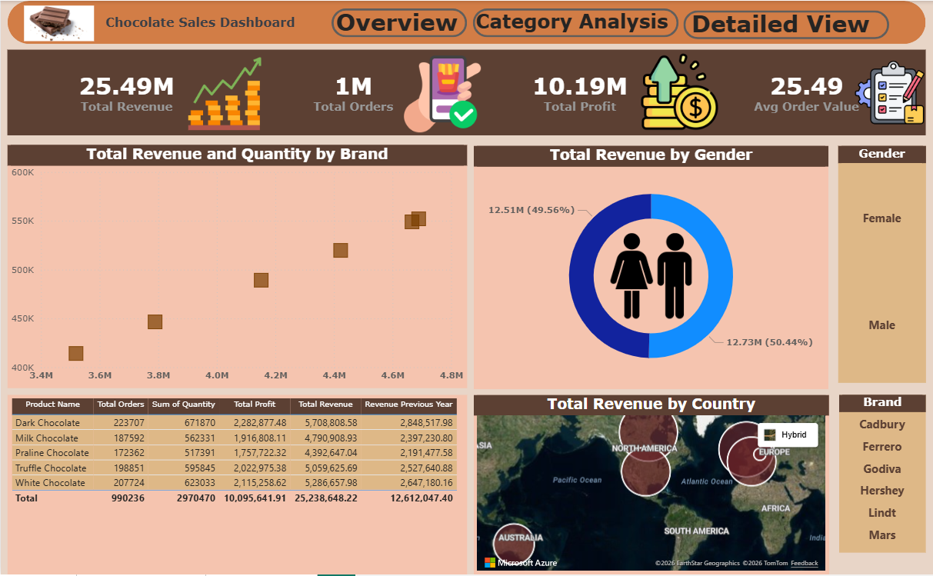
- Filtering Options: Users can filter this detailed view using slicers for Gender and Brand located on the right side of the page.
Business Questions:
🍫 Page 1: Overview Analysis
Field | Question 1 | Question 2
Question | What is the total revenue generated during the entire period? | Which product category has the highest sales proportion?
Visual Used | KPI Card | Donut Chart
Answer | $25.49M | Dark Chocolate (22.62%)

🍫 Page 2: Category Analysis
Field | Question 3 | Question 4
Question | Which month recorded the lowest total quantity sold? | Is there a significant difference in revenue between genders?
Visual Used | Line Chart | Pie Chart
Answer | February (233K units) | No, it is balanced: Male (50.44%) vs Female (49.56%)

🍫 Page 3: Detailed View
Field | Question 5
Question | Which brand achieved the highest balance between quantity and revenue?
Visual Used | Scatter Plot
Answer | Ferrero (positioned at the top-right of the plot)

